Ideation Phase
Define the Problem Statements

Date | 30 September 2026
Team ID | SWTID-2026-6284
Project Name | AI WEATHER WISE API
Maximum Marks | 2 Marks

Customer Problem Statement -AI WEATHER WISE API
People often struggle to get accurate, timely, and easy-to-understand weather information for their location. Sudden changes in weather, unexpected rain, extreme temperatures, and other conditions can affect daily activities, travel, work, and outdoor plans. AI Weather Wise API addresses this problem by providing real-time weather information, forecasts, alerts, and personalized insights in a simple and user-friendly way, helping customers make better decisions based on current and upcoming weather conditions.
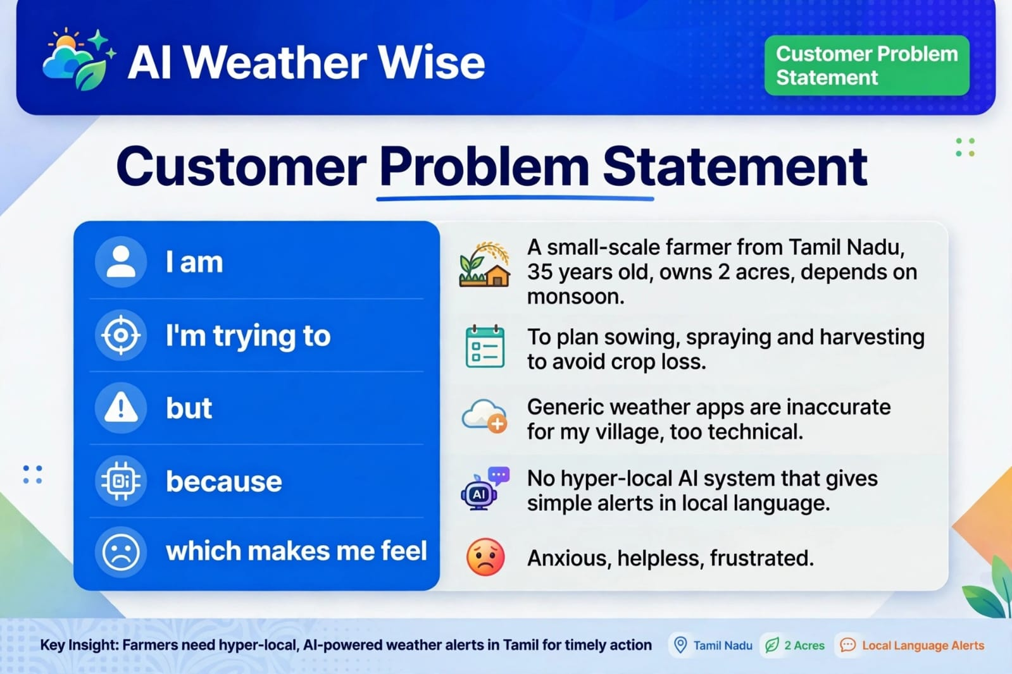
- Example:
